A284-Asia-India-Harappa-Zebu Bull-Pipal Tree-Terracotta-2600–1900 BCE

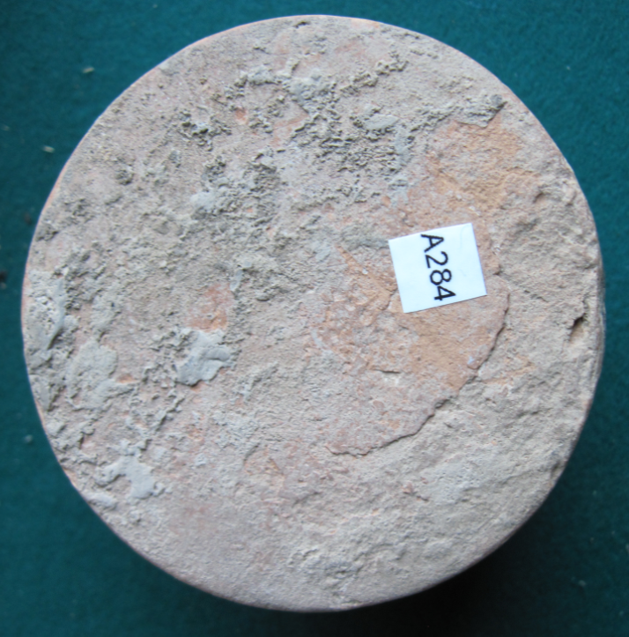 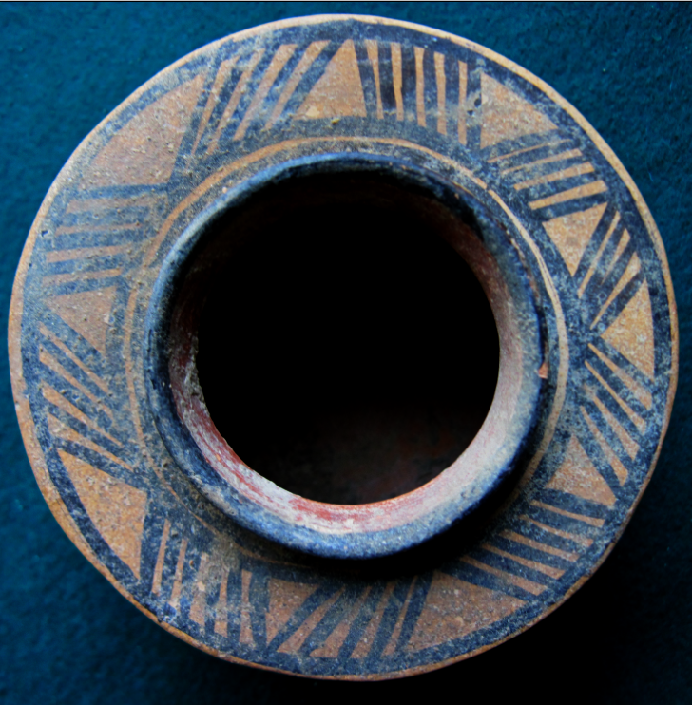 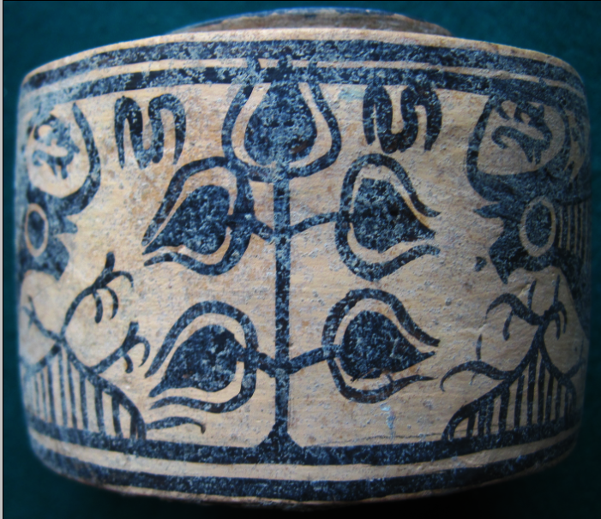

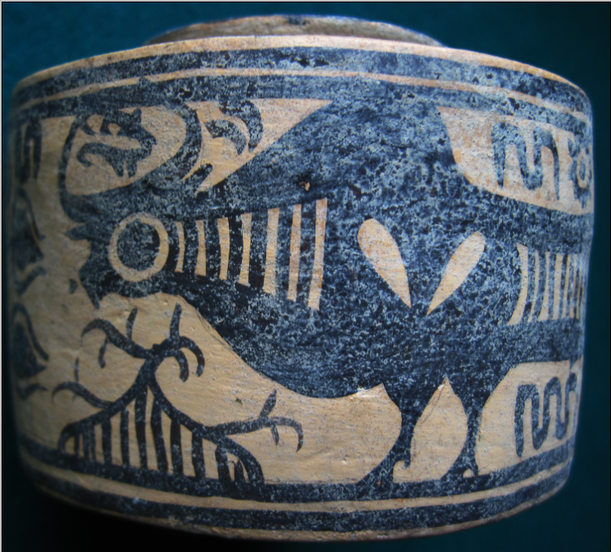 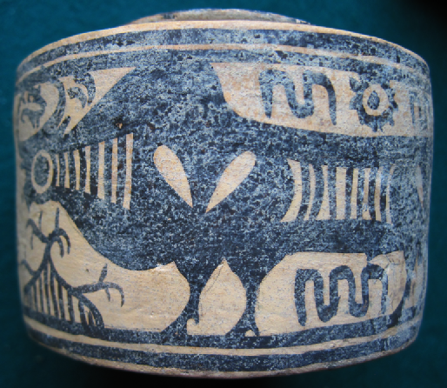

Figs. 1-5. Harappa-Zebu Bull-Pipal Tree-Terracotta-2600–1900 BCE

**Case no.: 3**

**Accession Number: A284**

**Formal Label:** Harappa-Zebu Bull-Pipal Tree-Terracotta-2600–1900 BCE

**Display Description:**

This 3000 BCE Harappa terracotta combines the symbolism of both the zebu bull and the pipal tree (*Jicus religiosa*). Zebu cattle were important in Harappa’s agrarian economy, and the zebu bull assumed a rôle as the symbol of fertility and fruitfulness. The pipal tree assumed its rôle as a symbol of enlightenment. The zebu bull’s image is unusual in that it suggests a linear interior structure, the meaning of which is unclear. It may simply reflect how Harappa pastoralists identified their domesticated cattle.

**LC Classification:** DS486 H35  
**Date or Time Horizon:** 2600–1900 BCE

**Geographical Area:** Harappa

**Map, GPS coordinates:**

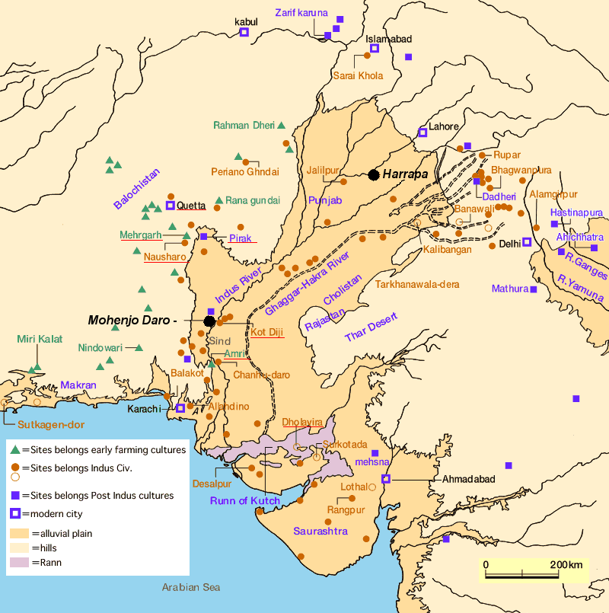

Fig. 6. Map of Indus sites from https://encrypted-tbn0.gstatic.com/images?q=tbn:ANd9GcSnoolUCyM4saSet1fqKCqzYEWJhfDBzJsATILKpXYgG8P2maLY.

**Map, GPS coordinates:** [27°19′45″N 68°08′20″E](https://tools.wmflabs.org/geohack/geohack.php?pagename=Mohenjo-daro&params=27_19_45_N_68_08_20_E_type:landmark)

**Cultural Affiliation:** Harappa

**Media:** Terracotta, black pigment

**Dimensions:** H 65.05, 2.56 in

**Weight: 227 gm, 8 oz**

**Condition: original**

**Provenance:** unknown

**Discussion:**

Following the Harappan civilization’s decline, northwestern India was settled by Aryan-speaking peoples who were pastoral and the economic importance of cattle is reflected in the ritual and symbolism of the Vedic literature of Hinduism. At this time-horizon 1900-1600 BCE, during the Hindu social transformation, the pipal tree became the symbolic abode of the Hindu trinity of masculine deities: Shiva, Vishnu and Brahma.

**References:**

Ratnagar, Shereen. 1981. *Encounters, the westerly trade of the Harappa civilization*. Delhi; New York : Oxford University Press.

Vats, Madho Sarup. 1999. *Excavations at Harappa: being an account of archaeological excavations at Harappa carried out between the years 1920-21 and 1933-34*. New Delhi: Director General, Archaeological Survey of India.